**SECTION – I**

Analogue to digital converter

Display(real time image)

v

CPU ( process the raw data signal)

Voltage pulse generator

**ULTRASOUND**

**IMAGING SYSTEM**

Transmitter/ receiver switch(Transducer probe produce sound waves and receives echoes)-piezoelectric effect

)

Amplifier

Human body

**FIG : DIAGRAM OF BUILDING BLOCK OF ULTRASOUND IMAGING SYSTEM**

1. The common image processing techniques include image preprocessing, image detection,

image enhancement, image segmentation, image registration, image interpretation.

1. Brain tissues(both white and grey matter) are very soft materials which disintegrate easily with the application of load over a few hundred kilopascals (kPA).

STRESS = load/ area

STRAIN= extension length/original length

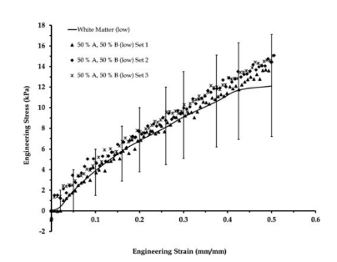STRESS STRAIN CURVE OF WHITE AND GREY MATTER AT LOW STRAIN RATE-Fig1

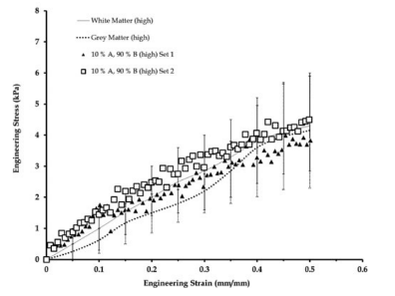

STRESS STRAIN CURVE OF WHITE AND GREY MATTER AT HIGH STRAIN RATE – Fig2

From the journal of BIOFIDELIC HUMAN BRAIN TISSUE SURROGATES , the brain tissue stimulants for both grey and white matter were tested in tension at two different strain rates(low and high) which shows that when stress applied on the tissue increases , the white matter of brain tissue has higher strain rate compared to grey matter of the tissue.

1. Kramers- Kroenig analysis of biological skin

Biological skin is a multilayered heterogeneous dielectric material. Three typical divisions of skin are epidermis, dermis and sub dermis layer, where epidermis is referenced as stratum corneum. Electromagnetic theory is used to calculate the dispersion index from the known absorption behavior through Kramers-Kroenig relation.

Kramers-Kroenig analysis of aggregate tissue absorption data yields a comprehensive dispersion curve spanning the entire frequency spectrum.

The convolution form of kramers-kroenig relation is given by 1.png

n= dispersion index; k= absorption

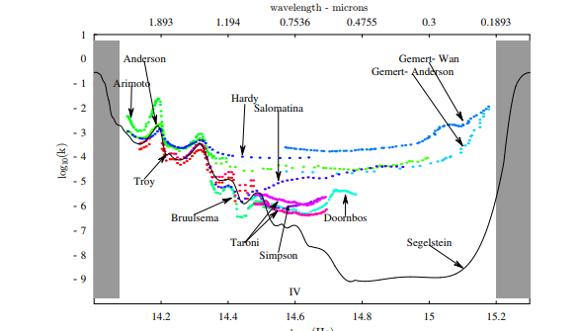

Fig: Absorption of human skin(colored points) Vs water curve(solid black line).

5. Diffraction is the slight bending of light as it passes around the edge of an object. The amount of bending depends on the relative size of the wavelength of light compared with the size of the opening. If the opening is much larger than the lights wavelength, the bending will be almost unnoticeable.

Scattering is the process by which particles suspended in the medium of a different index of refraction diffuse a portion of the incident radiation in all directions.

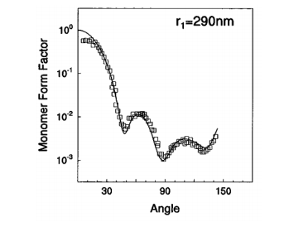

Fig 1: diffractive pattern of the light scattering

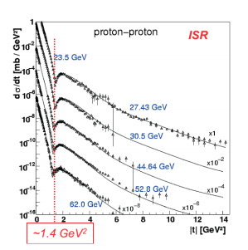

Fig 2: diffractive pattern of proton scattering

In fig 1: the angular distribution of the light scattering of a polystyrene latex particle is given.

The energy of the incident photon is aprox = 2.5 eV and the size of the particle scattering is near 0.3 mirco meter.

The above pattern given in fig 1, is compared with proton proton scattering at fig 2. Here the energy of collision is much higher: 1011/1012 eV , hence there is a huge difference in energy and scatter sizes.

6.

|  |  |  |  |  |
| --- | --- | --- | --- | --- |
| **Modality** | **Ultrasound** | **X-ray** | **Computed tomography** | **Magnetic Resonance** |
| **What is imaged?** | Images of soft tissues, movement of body’s internal organs and also blood flow in arteries | Bone-soft tissue interfaces, Images of tissues and structures inside the body | Cross sectional images of the body.  Images of bones, soft tissues, organs & blood vessels | Offers excellent details of soft tissue  Ability for functional imaging and 3D imaging. |
| **Access** |  |  |  |  |
| **Spatial resolution** | 4 | 3 | 2 | 5 |
| **Temporal resolution** | 3 | 4 | 5 | 1 |
| **Penetration depth** | 4 | 1 | 4 | 5 |
| **Safety** | 5(highly safe) | 1(least safe) | 3 | 4 |
| **Cost** | 4 | 5(cheap) | 3 | 1(costly) |
| **Speed** | 4 | 5(fast) | 3 | 1(longer time) |
| **portability** | 5(most portable) | 3 | 2 | 1(not portable) |

7**. LINEAR ARRAY PHASED ARRAY US PROBE**

LINEAR ARRAY

PHASED ARRAY

1.Shape of piezoelectric crystal arrangement is linear 1.shape of piezoelectric crystal

2.Shape of the beam is rectangular arrangement is curvilinear

3. Near field resolution is good 2. Shape of the beam is convex

4. largest transducer assemblies(256- 512 elements) 3. image resolution decreases when

the depth increases

4. contains (64 to 128)individual

elements

Factors in design of Ultrasound probes:

Crystal effectiveness, effect of baking material, acoustic impedance of probe, electromechanical coupling constant of the piezoelectric element, bandwidth, acoustic impedance of baking material, thickness and acoustic impedance of matching layer, etc..

8. The type of artifact present in ultrasound image is motion artifact, slice thickness artifact due to thickness of the beam.